
Shadsworth Junior School
Year 4 Homework Grid
Autumn Term 2023
EVERY CHILD TO COMPELTE THE “MUST DO” SECTION OF THE GRID
Children can then choose a selection of activities from the grid
Must Do Every Week:  Read a book of your choice every night for 15 minutes and write a comment in your home reading note book  Spend 15 minutes on Times Tables Rock Stars three time a week  Learn your weekly spellings given out in class | Science  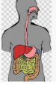  This Term, we have been learning about how our digestive system works.  Create a poster to show how the digestive system works.  Compare animal/birds digestive systems and write at least 3 facts about them both.
Writing    Write 3 sentences about what you have enjoyed about coming back to school.  If you could change 2 school lessons, what would they be and why?  Try to include one of these conjunctions in your writing: because, even though, if, when, so and as well as. | Maths  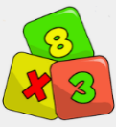  Practise your Timetables on TT Rock Stars or Purple Mash.  Get someone in your family to time how quickly you can say your 3 x , 4 x and 8 x tables.
Geography  This Term, we have been learning about Europe.  Write a holiday leaflet about a european country.  Include the physical and human features, languages, food and celebrations. | Creative  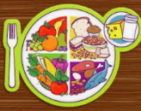  Design a healthy 3 course meal for a family of four.  Include a meal for people who are vegetarians.

Hand your homework book to your class teacher during the last week of each term. Pupils who complete all the work to a good standard will receive a reward.

