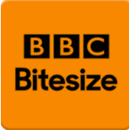
Own It - A place to help you boss your life online - Own It - BBC
Five ways to structure your day when you’re stuck at home - Own It - BBC
Eight ways to support your anxious child during the coronavirus pandemic - BBC Bitesize
Six ways to support your children as lockdown eases - BBC Bitesize
Seven techniques for helping kids keep calm - CBeebies - BBC (For Foundation and KS1 Children)

